**Assignment 15.2**

1. Partial function - Write a partial function to add three numbers in which one number is constant and two numbers can be passed as inputs and define another method which can take the partial

function as input and squares the result.

A function can be applied partially with an underscore, which gives another function.

Scala uses the underscore to mean different things in different contexts.

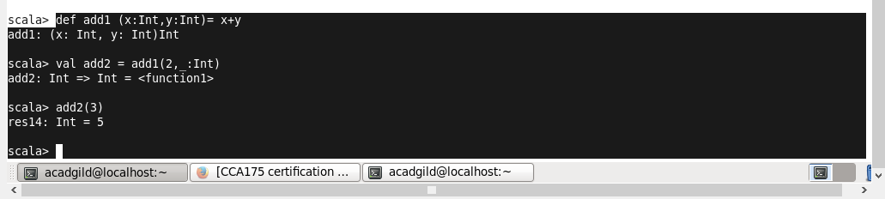

1. Match - Write a program to print the prices of 4 courses of Acadgild: Android-12999,Big Data

Development-17999, Big Data Development-17999, Spark-19999 using match and add a

default condition if the user enters any other course.

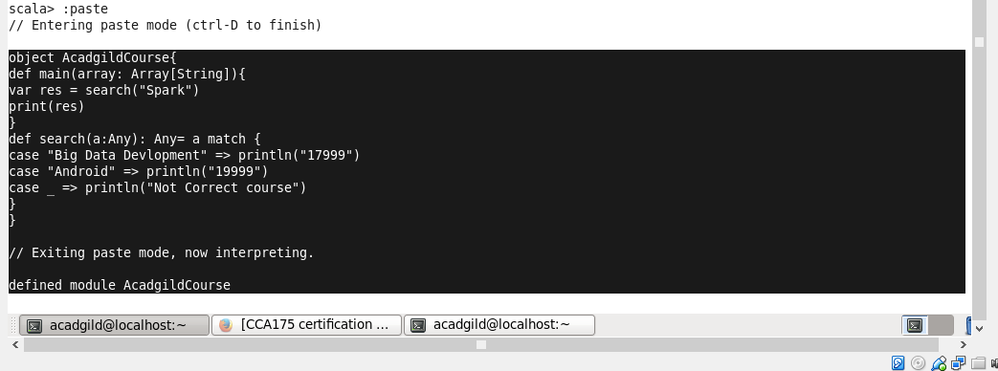

Output:

